Looking Into Abuse: Research by People with Learning Disabilities

Easy Read Study Plan

The idea for this research came from people with learning disabilities.

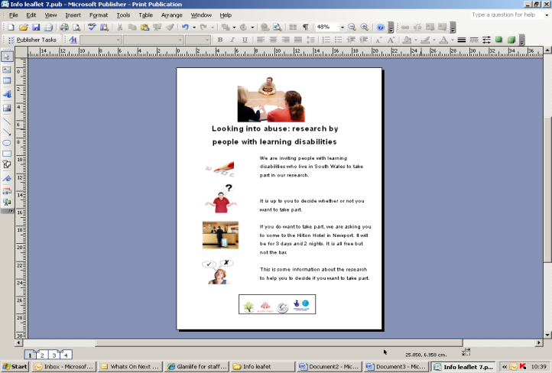

They wanted to find out more about what people with learning disabilities know about abuse and how they can keep themselves safe.

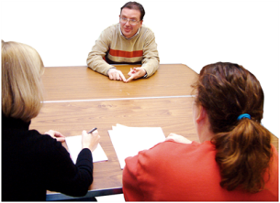

They also wanted to do research.

[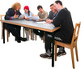](http://photosym.photosymbols-001.vm.brightbox.net/images/?page=2&SearchInput=meeting)We decided to work together to plan a study.

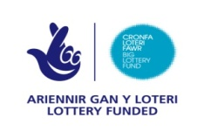We got money from the Big Lottery to do the research.

We started in May 2009.

[](http://www.google.ie/imgres?imgurl=http://www.easter-fun.com/pictures/easter-2013.jpg&imgrefurl=http://www.easter-fun.com/easter-2013-calendar.php&usg=__5evnuOTrW2AXnIXQCsc5Uni8TNY=&h=167&w=250&sz=8&hl=en&start=15&zoom=1&tbnid=vXjiIz_zyJWpPM:&tbnh=104&tbnw=155&ei=NX3STeSFPOT30gHwmLXECw&prev=/search?q=2013+calendar+easter&hl=en&biw=1020&bih=559&gbv=2&tbm=isch&itbs=1&iact=rc&dur=31&page=2&ndsp=16&ved=1t:429,r:0,s:15&tx=76&ty=7)The project will end in April 2013.

# The Research Team

These groups are working on the study:

* Rhondda Cynon Taff People First

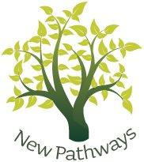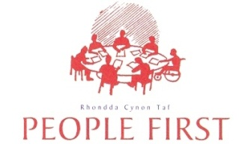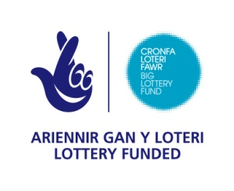







* New Pathways



* University of Glamorgan

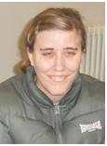These are the people who are working on the project:

* Sam

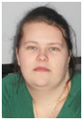

* Mel

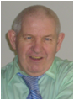

* Davey

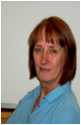

* Joyce



* Emma
* 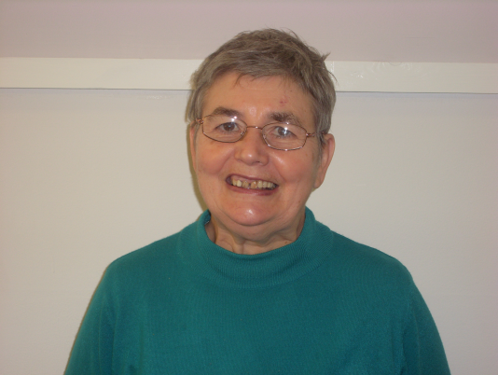Lyn



* Victoria



* Jackie



* Ruth

# Why We Are Doing the Research

[](http://photosym.photosymbols-001.vm.brightbox.net/images?utf8=%E2%9C%93&SearchInput=abuse)

People with learning disabilities are sometimes abused.

[](http://photosym.photosymbols-001.vm.brightbox.net/images?utf8=%E2%9C%93&SearchInput=silent)But:

* + - Sometimes people don’t always do anything about the abuse
    - [](http://photosym.photosymbols-001.vm.brightbox.net/images?utf8=%E2%9C%93&SearchInput=talking) People with learning disabilities are not always told what they can do about abuse
    - They are not asked how they feel about abuse



People with learning disabilities haven’t been involved in doing research very often.

This project wants to do something about these things.

# Research Questions



We want to answer these questions:



What do people with learning disabilities understand by abuse?

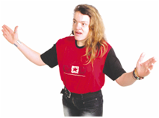

What are their views about abuse?

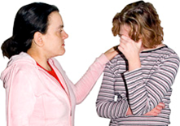What help and support do they need to keep safe?

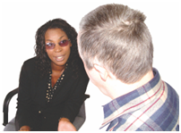When someone has been abused what are the best ways to help?

# What Have We Done to Get Ready for the Research?

[](http://photosym.photosymbols-001.vm.brightbox.net/images/?page=2&SearchInput=meeting)

We have met together regularly

We have talked about different ways of doing things

[](http://photosym.photosymbols-001.vm.brightbox.net/images?utf8=%E2%9C%93&SearchInput=training)

We have had training about how to do research

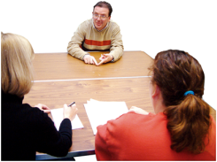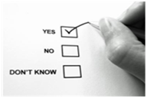We have tried out different ways of getting information

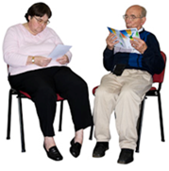

We have checked out with other people whether what we have written is easy to understand

do.jpgWe have talked about how we can keep people safe when we are doing the research (ethics)

# How We Will Do the Research

[](http://photosym.photosymbols-001.vm.brightbox.net/images?utf8=%E2%9C%93&SearchInput=library)

We are looking at what has been written about abuse and people with learning disabilities.



We will be putting this information together so that people with learning disabilities can use it.



We will be asking people with learning disabilities for information.

We will use three different ways to do this:



* We will ask people to fill in a questionnaire

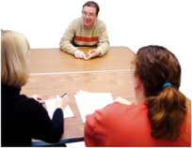

* We will ask people to take part in individual interviews
* 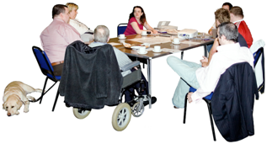We will ask people to take part in group interviews



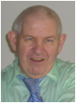Mel, Davy and Sam will do the individual and group interviews supported by Joyce or their personal assistant.

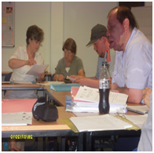We will ask people with learning disabilities from South Wales if they would like to come to a research residential.

This will be in November 2011.



At the residential people with learning disabilities who come will have chance to:

* fill in the questionnaire
* take part in individual interviews
* take part in group interviews

We will record what they say so that we can listen to it later.

They don’t have to come if they don’t want to.





[](http://photosym.photosymbols-001.vm.brightbox.net/images?utf8=%E2%9C%93&SearchInput=thumbs+up)

We will make sure that people are happy to take part.

We will ask them to fill in a form or tell someone to check that they are happy to take part.

We will ask people who cannot come to the residential if they would like to fill in the questionnaire.

[Out and About Object Objects Letters Letter Mail Post Postage Post letter Post box](http://photosym.photosymbols-001.vm.brightbox.net/images?utf8=%E2%9C%93&SearchInput=post)They can post the questionnaire back to us.

[](http://photosym.photosymbols-001.vm.brightbox.net/images?utf8=%E2%9C%93&SearchInput=wales)

This will mean that people from other parts of Wales can take part in the study if they want to.

# How Will We Ask People to Take Part?

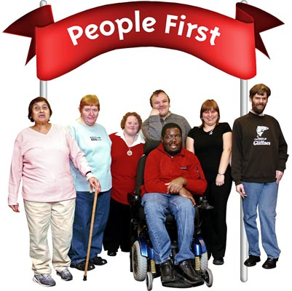

We will write to People First Groups to tell them about the research.



[](http://photosym.photosymbols-001.vm.brightbox.net/images?utf8=%E2%9C%93&SearchInput=dvd)We will send them some information leaflets and a DVD so that they can make up their mind if they want to come or not.

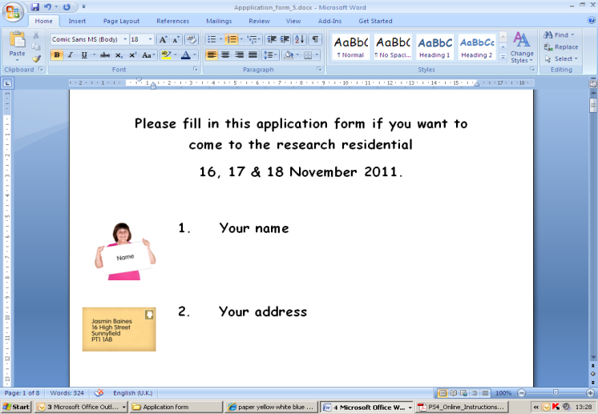If they do want to come we will ask them to fill in an application form and to send it back to us.

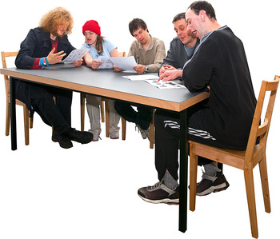

We will then tell them if they have a place.



For the postal questionnaire we will send them out to People First groups and ask them to fill them in.

If they are happy to do this we will ask them to send them back to us when they have been filled in.

## What Will We Do With What We Find Out



The research team will look at what people said in the individual interviews and the group interviews.



We will talk about what they have told us.

We will see if people say the same things.

We will also look to see if people say different things.



With the questionnaires we will look to see how many people tick the different boxes.

[Actions Hold Object Body Part Hand Literacy Pen Holding Write Writing](http://photosym.photosymbols-001.vm.brightbox.net/images?utf8=%E2%9C%93&SearchInput=write)[](http://photosym.photosymbols-001.vm.brightbox.net/images?utf8=%E2%9C%93&SearchInput=report)

We will write about what we find out.



# Keeping People Safe (Ethics)

do.jpg

These are the things we will do to try and keep people who take part in the research safe:

* We will give people easy read information and answer any questions they have.



* We will make sure they know they do not have to take part if they don’t want to
* We will make sure they know they can stop taking part at any time.

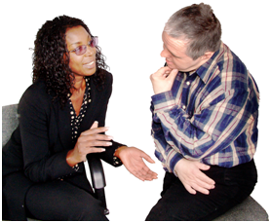

* This will help them to make a decision about whether to take part.



* We will check each time we collect information that they are still happy to take part.



* 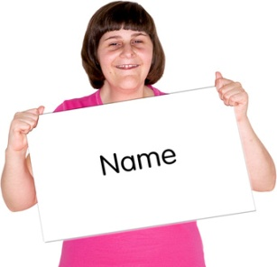We will make sure that people’s names are not in any reports of the study or in any presentations we make.



* 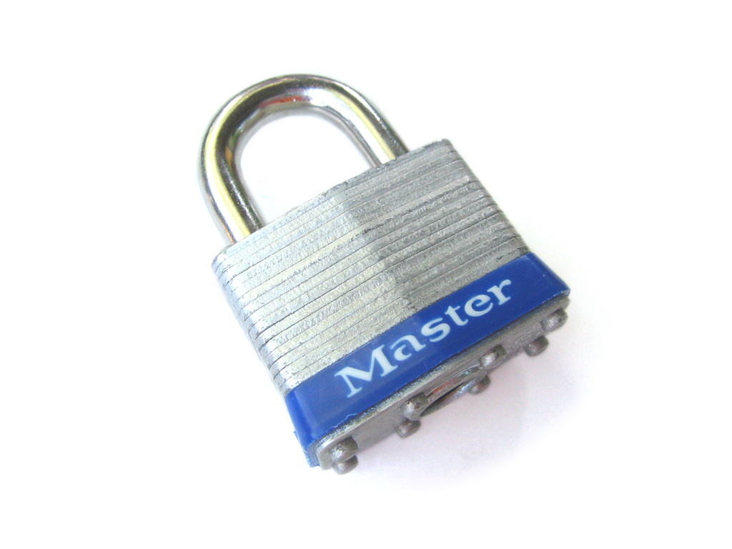[](http://www.google.ie/imgres?imgurl=http://www.faqs.org/photo-dict/photofiles/list/1483/9437lock.jpg&imgrefurl=http://www.faqs.org/photo-dict/phrase/1483/lock.html&usg=__6WeOxfLbPKzmcuv6Kbfac7mwVEU=&h=700&w=596&sz=73&hl=en&start=10&zoom=1&tbnid=B-9LwNU8NNCswM:&tbnh=140&tbnw=119&ei=5JrSTZadEoi7hAfVgYH8CQ&prev=/search?q=lock&hl=en&biw=1020&bih=559&gbv=2&tbm=isch&itbs=1)We will keep all information we are given safe.



* We will make sure that people know if they tell us that they or someone else is being hurt, or that they are hurting someone, then we will have to tell somebody.
* 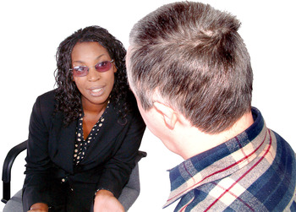People may get upset by talking about abuse so we will have counsellors at the residential that they can talk to.

We also know that the research team may get upset listening to other people taking about abuse.



We will make sure that the researchers know that they can also talk to the counsellors.

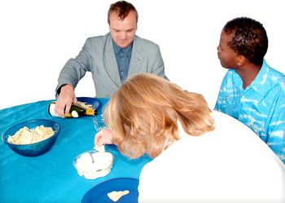

The research team will also meet at the end of each day during the residential to talk about how things are going.

# How Will We Let People Know What We Have Found Out?

[](http://photosym.photosymbols-001.vm.brightbox.net/images?utf8=%E2%9C%93&SearchInput=report)

We want to make sure that as many people as possible know about what we find out.

This will include:

* 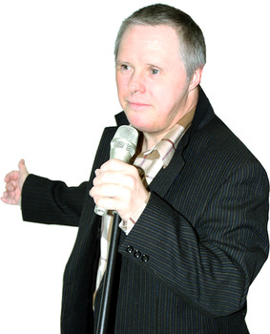People with learning disabilities
* Their families and carers
* Professionals
* People who make policies
* Researchers

We will use the following ways to get the information to these people:

[Actions Hold Object Body Part Hand Literacy Pen Holding Write Writing](http://photosym.photosymbols-001.vm.brightbox.net/images?utf8=%E2%9C%93&SearchInput=write)

* 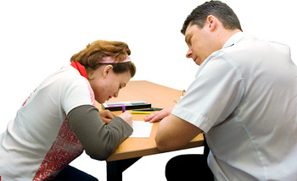We will write articles

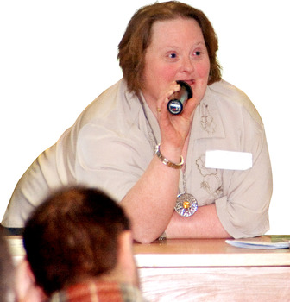

* We will give presentations at conferences
* We will make posters

[](http://photosym.photosymbols-001.vm.brightbox.net/images?utf8=%E2%9C%93&SearchInput=website)

* We will put information on the web

# Project Timeline

June 2011 Ethics committee

July 2011 Practice interviews

Invite people to residential

August 2011 Practice interviews

September 2011 Follow up invitations to residential

Prepare for the residential

October 2011 Visit Hotel to make final arrangements

November 2011 Residential

January 2012 Send out postal questionnaires

Continue work on literature review

February onwards Look at the information we have collected

January 2013 Send out accessible literature review

February 2013 Finish project report

Complete articles

May 2013 Project ends